(Logo of your company) | VIETNAM COMPANY’S PROFILE  (Exporter)

I/ COMPANY INFORMATION

Company Name
Address
Telephone (s) | +84- |  | +84-
Fax
E-mail (s)
Website
Tax code (company) |  |  | Date:
Legal Capital (US$)
Number of staff
Trade Value (last year) | Export (US$): | Import (US$):
Main countries
(Export/Import)

LEGAL REPRESENTATIVE CONTACT PERSON

Name | Mr./Ms | Name | Mr./Ms
Position |  | Position
E-mail |  | E-mail
Mobile |  | Mobile
Facebook  (if necessary) |  | Facebook  (if necessary)

DETAILS OF BUSSINESS
Main sectors | Manufacturer [ ] | Trading [ ] | Service [ ] Management [ ]
Summary in activities
Product name (Export)
Request to attend the trade fair in West Africa

II/ PRODUCTS (EXPORT)
No | Product Picture (250 pixels max) | Name, specification, HS code of product
1 | 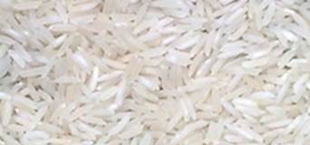  (thay ảnh sản phẩm của quý công ty) | Ví dụ:  Long grain rice, 5% broken  HS code: 10063001  Milled or wholly milled rice  whether or not polished or glazed  (thay thông tin sản phẩm của quý công ty)
2

…..

III/ ACTIVITIES OF COMPANY

No | Picture (250 pixels max)  (Ảnh minh họa về DN, hoạt động của DN) | Picture (250 pixels max)  (Chú thích đính kèm)
1 | VD: Head Office (thay ảnh của DN) | 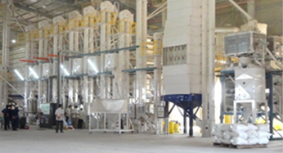  VD: Rice Milling Factory (thay ảnh của DN)
2

…
…

This form filled in & approved by CEO/Director of Vietnam company on: dd/mm/yyyy;
The information declared as above mentioned is true and in accordance with the Commercial law of Vietnam.

*********

Note:
Using the following software to reduce the size of pictures “Capture pictures on the screen”’.
1) http://www.mirekw.com/winfreeware/files/MWSnap300.exe
2) Using “ Spinning Tool” in your computer (Window 7, 8 & 10)

Recommendation & warning by Vietnam Trade Office in Nigeria:
- The payment has to be done by the Irrevocable Letter of Credit At sight (L/C).
- Do not apply: T/T (Telegraphic Transfer) 20% (30%) before shipment, 80% (70%) after shipment, or D/A (Document against Acceptance);
- The exporter and importer have to bear any risk, if do not follow the above recommendation, and are responsible for their transaction of products, payment.

Vietnam Trade Office in Nigeria
(Concurrence with Ghana, Cameroon, Togo, Chad, Sierra Leone & Liberia)
No. 21, The Address Home#1 Estate,
Castlerock Ave., Lekki, C.P. 106104, Lagos city, Nigeria
Mp/WhatsApp: +234 803 474 4486
Emails: ng@moit.gov.vn; VietHoangTuan@gmail.com
https://vnembassy-abuja.mofa.gov.vn
http://en.vietnamexport.com/

